Exception Handling

Key Terms
try block
throw statement
exception
throwing an exception
catch block
handling an exception
exception handler
catch-block parameter
catch (…)
exception specification
throw list
Warning!
bad_alloc

Brief Outline
18.1 Exception Basics
A Toy Example of Exception Handling
Defining Your Own Exception Classes
Multiple Throws and Catches
Pitfall: Catch the More Specific Exception First
Tip Exception Classes Can Be Trivial
Throwing an Exception in a Function
Exception Specification
18.2 Programming Techniques for Exception Handling
When to Throw and Exception
Pitfall: Uncaught Exceptions
Pitfall; Nested try-catch Blocks
Pitfall: Overuse of Exceptions
Exception Class Hierarchies
Testing for Available Memory
Rethrowing an Exception

1. Teaching Suggestions

Most programs, in particular student programs, are written under the most optimistic of assumptions, namely, that nothing will ever go awry. Clearly, only a "Hello World" program may be simple enough for this to be reasonable. Errors that must be planned for abound. Input values may be out of range, a hardware unit may fail, or the desired removable medium may not be in the drive, a stack may overflow or underflow, or an array index may take an illegal value. Most programmers agree that these errors are exceptional events.

However, to define exceptional events to be only error conditions is too restrictive. It is likely better to think of exceptional conditions as situations that, while rare, managing them necessitates moving from one phase of a program to another or, possibly, termination of the program. For example, end-of-file may signal that we are through entering data, and are starting the computation, or that the data file may be erroneous. There is no clear dividing line between events that are error exceptions and events that are normal exceptional events.

2. Key Points
Exception Basics. An exceptional event is any event or condition that
- prevents completion of an operation that in turn detects the condition,
- either cannot be resolved in the local context of the operation, or is better resolved elsewhere and
- must be brought to the attention of the operation's invoking entity.
An exception, or exception object, is a data structure that communicates information to the handler sufficient for the handler to manage the exceptional situation.

An exceptional event may be detected anywhere after the exceptional event occurs but should be detected as soon as possible after the event occurs. An exception may be handled anywhere after it is detected, but should be managed in a part of the code that understands the exception. This is usually in the caller of the function where the exception is detected or somewhere up the call chain, perhaps in the main function itself. For example, a library author cannot know whether the failure of a removable disk drive should be grounds to terminate the program or the user should be asked insert media in the drive and try again. The caller can know, or find out.

In C++, an unhandled exception causes abnormal program termination. Facilities for exception handling detect the unusual situation and collect information about these occurrences in a program unit. The facility then transfers control and the information up the chain of invocation to some level that understands the situation. The higher-level system then manages the situation.
In C++ an exception object may be any type. This includes primitive values of type char, int, float, a C-string literal, or an object of any class. The class may be an exception class defined in the Standard C++ Library, a class derived from a library exception class, or a class defined by the programmer. What makes an object an exception object is determined by how the object is used.

The purpose of the exception object is to send information necessary to manage the situation from the place where the exceptional event is detected to the handler in a program entity that has enough additional information to manage the error.

A Toy Example of Exception Handling. A key point here is that to catch an exception the code that throws the exception (or calls a function that throws the exception) must be placed in a try block that is immediately followed by a catch block.
try
{
ExceptionType exceptionObject; //define exception object
// The code may detect an exceptional situation.
// If so the Boolean variable, situation, is set to true.
if(situation)
throw exceptionObject(argumentList);
// code here is executed ONLY if the exception is not thrown
}
catch(ExceptionType name)
{
// This code is reached ONLY if the exception of type
// ExceptionType is thrown.
// The code here does whatever must be done to manage
// the exceptional situation.
}

The try block is the code between the curly braces following the keyword try. The catch block begins with the declaration of the exception object to be caught and includes the code in the block following the keyword catch.

Control is transferred directly from the throw statement to the catch block. The type of the object declared must exactly match the type of the exception object that was thrown. In C++, this process is called throwing an exception. The code in the catch block is said to handle the exception.

The exception need not be caught locally. Indeed, the more usual situation is to transfer control to the caller or further up the call chain. Below we call a function in our try block that is able to throw an exception of type ExceptionType.

// code is a function that calls a lower level function where an
// exception of known type is thrown.
try
{
//Code preparing for the function call
functionThatThrowsAnException(argumentList);
// code here is executed ONLY if the exception is not thrown
}
catch(ExceptionType exceptionObjectName)
{ // code is executed here ONLY if the exception is thrown
// AND is caught by this catch block.

// whatever needs to be done to manage situation
// causing the exception to be thrown in the function
}

Again, we point out that control is transferred from the throw statement in the function that we call in the try block directly to the catch block where the type of the object declared must match exactly the type of the exception object that was thrown. The exception object carries the information provided to it in the call. The catch block handles the exception.

The "clean up" that would be done in the functions between the throw and the catch is carried out as if functions had terminated normally. In particular, all stack frames between the function that throws the exception and the catch block are popped off the run-time stack. This is called "unwinding the stack". This deallocates all the local variables. All destructors that would be called if the intervening functions terminated are called.

Defining Your Own Exception Classes. In C++, any type can be used for an exception. What makes an object an exception is that it is thrown in a try block (or in a function called in a try block) and caught in the corresponding catch block. The only requirement for an object to be an exception is that the object be able to convey sufficient information that the exceptional event can be managed. An int could be an out of bounds array index. This could be used in a context where the fact that an int type exception was thrown means that there was an out of bounds array index, and the value could be the invalid index.

The exception name may convey all the information needed. In this circumstance, a trivial class suffices. Such a circumstance occurs in Display 18.4, where a trivial exception class DivideByZero is used. The fact that this exception was thrown is all the information needed. In Display 18.4, the exception class DivideByZero is defined at line 16, the throw statement is at line 35, and the corresponding catch block starts at line 44.

Multiple Throws and Catches. If the try block might throw several different types of exception objects, there is a catch blocks needed for each type exception to be caught. See Display 18.4 line 22 and following where the code may throw two different types of exceptions, and the catch blocks at lines 39 and 44. The similarity of appearance between overloaded function definitions and catching exceptions of different types is more than coincidence. The same mechanism is used to decide which catch block is selected as for overloaded functions—with one exception. Only exact matches work with catch blocks. No automatic type changes (coercions) are carried out to cause a match as they are with overloaded functions.

Throwing an Exception in a Function. We have, from the start of this IM Chapter, envisioned that an exception would be thrown in a function but would be caught and managed by some caller of this function. Display 18.5 is an example of this scenario. Note that the try block (line 18) contains a call to the function double safeDivide(int, int), but there is no throw in the try block. The throw is in the function. Since the exception is not handled in the function, safeDivide(int, int), the exception is propagated up the call chain, and is caught in the calling function, main.

Exception Specification. The C++ Standard provides a mechanism for notifying the compiler and reader of the code what exceptions the function is expected to throw. This is called the exception specification.
double safeDivide(int, int)throw(DivideByZero);
If safeDivide throws an exception in the list, then the exception processing is done in a normal manner. If an exception is thrown that not in the list, then some compilers will give an error or a warning, other compilers will not warn about this. The Standard provides that in this situation, the function unexpected() should be called. The default behavior of this function is to terminate the program. Compiler Caveats: Some compilers allow changing the default behavior of unexpected, and some do not. Some compilers ignore throw lists entirely. Choose your compiler carefully and read the documentation. Experiment. Your compiler may not have read the documentation (that should have been) distributed with it.

Exception Class Hierarchies. Cline, Lomow, and Girou, in C++ FAQs 2nd say that use of exception classes in the form of a monolithic hierarchy of a singly rooted inheritance tree is best. This is an exception to the usual C++ rule that class hierarchies should be a forest of trees. Notice that this does allow you to catch the base class in the exception hierarchy to catch all uncaught exceptions, and be able to extract information from the exception object that is caught. Use of the ellipsis catch-all catch statement leaves the programmer with little more information than some body, somewhere threw an exception, and little alternative to attempting to save the client's work and terminating the program.

Testing for Available Memory. Under the old standard, the o If there was insufficient memory available to the program for operator new to allocate the requested amount of memory, operator new returned a 0.

Fairly recent changes in the C++ Standard provide different behavior. If there is insufficient memory available to the program for operator new to allocate the requested amount of memory, operator new will throw a class bad_alloc exception, which is defined in the standard library. The text gives a short example.

Rethrowing an Exception. If you need to catch an exception, partially handle the event, then have the rest of the handling done further up the call chain, it is legal to throw the same exception, or a different one from within a catch block. This exception will have to be handled by some caller, just like any other exception.

3. C++ Standard Exceptions
C++ provides a hierarchy of exception classes for a collection of possible conditions. This classification attempts to provide an organization for exceptions beyond those used by the standard library. These classes are declared in <stdexcept>. Here is the complete inheritance hierarchy.
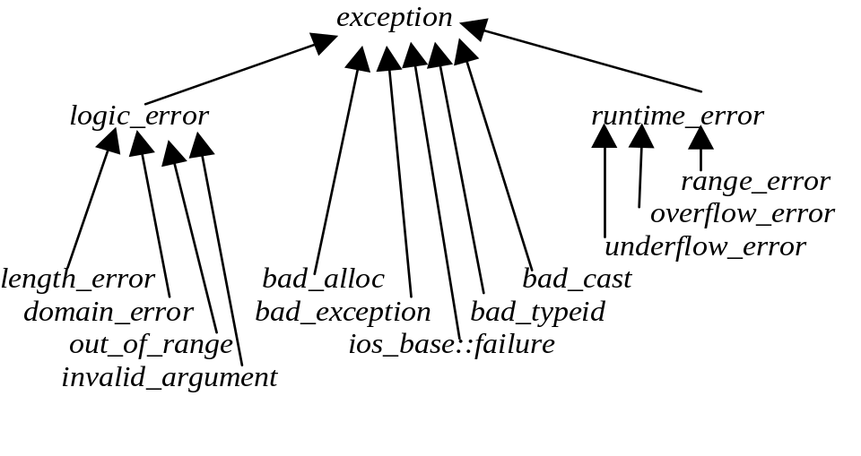
The class exception is a base class for all library exceptions, and may be used to catch all exception in the exception inheritance hierarchy. Programmers and library implementations may add exceptions that can inherit from the base class exception but this is not necessary. Use of these non-standard exceptions makes your code less portable. A particular exception may or may not be have class exception for its base class.
The text and the references recommend that more specific exceptions be caught be for using umbrella exception catching. I offer here two "exception umbrella" bits of code.
try
{
// code that may throw an exception
}
catch( exception e) // any exception derived from library class
// exception will be caught here.
{
// code to manage the exception
}
The preceding code will catch any exception that is derived from the library class exception, because anything derived from class exception already an exception class object and will match class exception. No catch following this will ever see an exception derived from class exception.
try
{
// code that may throw an exception
}
catch(...) // any exception will be caught here.
{
// code to manage the exception.
}
This bit of code will catch any so far uncaught exception No catch clause following this bit of code will ever see an exception. This should be the last catch clause in the main function of any program.

The following exceptions are derived directly from the class exception and are used in language support. We present these for completeness only. More extensive discussion of these is beyond the scope of this Instructor's Resource Manual.
Standard Exceptions (thrown by facilities in the language)
Name | Use, Thrown by | Header
bad_alloc | Global operator new | <new>
bad_cast | dynamic_cast | <typeinfo>
bad_typeid | RTTI, runtime type identification | <typeinfo>
bad_exception | exception specification | <exception>
ios_base::failure | used to detect i/o errors that are usually ignored. | <ios>

The following exceptions are used for the Standard Library and may be used by application programmers. The programmer, at least in principle, can avoid a logic error, perhaps by carrying out additional data or function argument validation.

Standard Exceptions, derived from logic_error, thrown by Standard Library
Name | Thrown by | Header
domain_error | Used to report that a function's argument is outside the set of values the function can accept. | <stdexcept>
invalid_argument | bitset constructor | <stdexcept>
length_error | standard string | <stdexcept>
out_of_range | Indexed STL container at() member.  Used to report that an argument values is not in an expected range as when a bad index is used in a string, or an array like collection | <stdexcept>
Standard Exceptions, derived from runtime_error. These are used to report errors beyond the scope of a program and are not easily avoidable.
range_error | used to report internal computation range errors | <stdexcept>
overflow_error | used to report an arithmetic overflow | <stdexcept>
underflow_error | used to report an arithmetic overflow | <stdexcept>

4. Tips

Exception Classes Can Be Trivial. We pointed out earlier that the exception name might convey all the information needed. We gave as an example the circumstance of catching a divide by zero error using class DivideByZero. The fact that this exception was thrown is all the information needed.

When to Throw an Exception. Not every program should use exceptions. Though C++ has exception handling, a programmer should use other error handling techniques when appropriate, for example, returning an error code. The decision which to do is the decision of the code author. If the program is intended for situations where the code should not crash, then the library must handle exceptional situations or pass the anomaly back to the client code, which then must handle the exception.

The exception facility was intended to communicate information about anomalies between parts of the program that were developed independently. We have mentioned the example of a library signaling an anomalous event to client code. The client code likely knows better how to manage the exception than the library writer.

5. Pitfalls

Catch the More Specific Exception First. The idea here is that this catch block will catch all exceptions not caught so far.
catch(...)
{
// code handling exception of undetermined type
}
catch(int intException)
{
// code handling int type exception
}
The int catch block will not catch anything because the catch block with the ellipsis (. . .) will catch any exception so far uncaught. The point is, put any catch blocks with an ellipsis last.

Uncaught Exceptions. Put bluntly: "C++ prescribes the death penalty for uncaught exceptions."
A program that throws an exception but does not catch it suffers abnormal termination.

Nested try-catch Blocks. Resist any temptation to nest try-catch blocks in another try block. There is usually a better program organization. A suggestion might be to write a function that detects the problem and throws an exception, which you can catch in a catch block, which you add to the function where you were tempted to nest.

Overuse of Exceptions. Like all programming language features, an exception facility is subject to abuse, resulting in code that us unreadable and unmanageable.

Some don'ts: Don’t use exceptions to control the flow of control in a program. Don't use exceptions when another technique to manage the exceptional situation is available. Don't let students with C experience use setjump() and longjump() for error handling in C++ programs. These transfer control out of the function without unwinding the stack, consequently without calling destructors for automatic objects. If C++ exceptions are used, then the stack is properly unwound and all destructors are called appropriately.

Some Do's: Do throw an exception in any software unit that cannot fulfill its promises, such as its post conditions, given that the preconditions are satisfied. Do name exception classes according to the error, not according to the thrower. Do provide a message in the exception class that the thrower can insert into the object at the throw statement for extraction by the catch statement.

